**Name of the Project:** Phase-3 Project [Make an E-commerce Website for Sporty Shoes]

**Problem Statement:** As a Full Stack Developer, build an E-commerce portal for Sporty Shoes.

**Objective:** manage the products in store including categorizing them, browsing list of users who have signed up and see purchase reports filtered by date and category

**Product capabilities:**

1. Managing Products:
   1. Add Product : (<http://localhost:8080/products/add>) type: GET
   2. Delete Product : ([http://localhost:8080/products/delete/{id}](http://localhost:8080/products/add)) type: GET
   3. Update Product : ([http://localhost:8080/products/update/{id}](http://localhost:8080/products/add)) type: GET
   4. Search Products by
      1. Id: ([http://localhost:8080/products/product/{id}](http://localhost:8080/products/add)) type: GET
      2. Season: ([http://localhost:8080/products/product/season/{id}](http://localhost:8080/products/product/season/%7bid%7d)) type: GET
      3. Brand: ([http://localhost:8080/products/product/brand/{id}](http://localhost:8080/products/product/brand/%7bid%7d)) type: GET
      4. Category: ([http://localhost:8080/products/product/category/{id}](http://localhost:8080/products/product/category/%7bid%7d)) type: GET
      5. Price: ([http://localhost:8080/products/product/price/{id}](http://localhost:8080/products/product/price/%7bid%7d)) type: GET
      6. Color: ([http://localhost:8080/products/product/color/{id}](http://localhost:8080/products/product/color/%7bid%7d)) type: GET
      7. Date: ([http://localhost:8080/products/product/date/{id}](http://localhost:8080/products/product/date/%7bid%7d)) type: GET
2. Browsing list of Users: Used to View user’s which are registered on the website. (<http://localhost:8080/users/all>)
3. Querying through purchase order list: query the product table and user tale based on product order and filter the data based on URL specified date and category. (<http://localhost:8080/products/product/userproduct?date=10/10/2020&catagory=all>)

**Database Tables:**

1. Product Table:

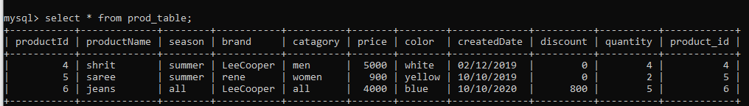

1. User Table:

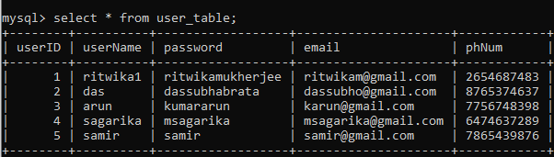

1. Product Order Table:

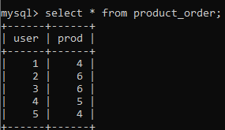

**Sprint Planning Details:**

No of Sprints: 2

No of User Stories: 3

No of tasks: 6

Tasks are as follows:

1. MySQL table creation: user table, product table.
2. Model class creation for product and user.
3. Repository creation of user and product.
4. Controller class creation and implementation of user and product.
5. Created product order table and linked all the tables.
6. Created data filtration a queried tables using product order table, product table and user table.

**List of the core concepts used are as follows:**

1. MySQL
2. JPA
3. Spring Boot
4. RestFul API.

**GitHub Link for the course code:** https://github.com/ritwikam2020/PhaseThreeProject